delicaSiz
Pinoy kakanin delicacies

Members:

Anjao, Diolina E.
Apsay, Aira Mae T.
De Guzman, John Mark M.
Guzon, Angelica Mae C.
Manalo, Jhomhike P.

Executive Summary
DelicaSiz is a Filipino business enterprise that caters Filipino delicacy called “kakanin”. It offers variety of kakaninlike cassava cake, biko, bukayo, suman moron, ubehalaya, nilupak and other varieties of rice cakes that are well known in the country. DelicaSiz is preparing native delicacies with fresh from the farm ingredients. Kakanin is a common snack in the country. Filipinos have created many different kinds of rice cakes. In local language, it is called kakanin,derived from the word kanin, meaning prepared rice. The business will also offer some products that is perfectly complements the food that we are offering. Beverages like iced coffee and chocolates are also available in the said business. In the next more years, the company envisions the DelicaSiz as the most well-known kakanin restaurant with more branches around the Philippines. DelicaSiz will establish a name besides well-known local and international stores that will show the uniqueness of the Filipino-made kakanin.

VISION:
To achieve our customers tongues and give them good service and nutritious food that would help their body composition and variety of food that surely enjoy.
MISSION:
To provide a quality products and healthy foods for all ages.

Problem & Solution

Problem Worth Solving
The problem we realized that most of the people in our barangays didn’t taste different type of merienda like biko, cassava, tupig, bukayo, suman moron everyday or in the day they want,because the market is so far for them to go for just buy these foods.

Our Solution
It is important for us to address the problem to have a corresponding solution for it. That’s why our business would be the answer for in that problem. They don’t need to go far just to taste pinoy delicacies everyday they can simple go outside and walk near our store and chose whatever they want to buy in our products which serve them nutritious delicious and affordable.

Target Market
The target market of our farm and restaurant business will be the retailers, residents, passers-by, specifically the travelers and walk-ins along the location, workers, students, and anybody of all ages who wishes to have a taste of good Filipino delicacies.

Competition

Current Alternatives
DelicaSiz is the new but competitive restaurant that caters native delicacy in the area. This creates an intensely competitive environment with a large number of industry participants. Since almost all of the produce is considered to be commodities, and large scale buyers are more consolidated than the farmers themselves, overall margins are small and rivalries for wholesaler contracts are strong.

Our Advantages
The advantage of DelicaSiz is that the company harvest the raw products on its own plants. Where as you will see the farm within the store itself. DelicaSiz promotes eco-friendly culture. The customer will experience using utensils from the firm’s own plants. The company can give a little profit to the people who are in the small society to have some things to do while making a profit. With the right use of the plants both human and nature will benefit if we continue to take care of each other. The advantages is not just on one side, it should be a give and take for the better.
The company’s goals in the first year are to:
- Increase the total income of your company by 10% over the next two years.
- Reduce production expenses by 5% over the next three years.
- Develop and launch three new products.
The company’s long-term plan is to increase the revenue derived from identity-preserved crop production.
Execution
Marketing Plan
The Philippines is known to be abundant in natural resources that can be found in the surroundings. Some of these are crops, trees, plants etc. The resources that are naturally gifted to the nation can produce goods that can be introduced to acceptable goods of the country, which can be an economic livelihood, and a source of income. The country is also known for its delicious food. Among these foods are what we call “KamotengKahoy/kakanins”, native delicacies that are served as desserts. Each region develops their own delicacies throughout their history. No party or celebration is complete without these Filipino desserts.
The group decided to pursue this business since in the area, we rarely see stores that serve sweet delicacies and there are people who find these in the market. Usually, we can only buy this on street vendors and a lot of Filipinos who are classified as “senior citizens” know how to make these desserts as they have already become part of the Philippine traditions. Since there are different “KamotengKahoy/kakanin” that can be found in the country, we chose the most preferred delicacy which can give us, Filipinos the satisfaction. Like popular street foods, they are usually sold in the streets, at school, beside the church, etc. Some are more popularly served during fiestas. Most of these Filipino food recipes require simple ingredients that can be easily bought in the market.
Since there are different “Kamotengkahoy/kakanin” that can be found in the country, we chose the most preferred delicacy which can give us, Filipinos the satisfaction. Like popular street foods, they are usually sold in the streets, at school, beside the church, etc. Some are more popularly served during fiestas. Most of these Filipino food recipes require simple ingredients that can be easily bought in the market.
Situation Analysis
The name of our establishment will be DelicaSIZ since the filling of our product which is the pies are made from Kamotengkahoy/kakanin or delicacies like moron and Sapal. One of our mission is to serve and promote local delicacies to the localities and tourists, to provide employment to the local community and let people encourage, appreciate, patronize our own local delicacies.
The basic market need is high-quality with flexibility in production for both the consumer and commercial market.
SWOT Analysis
The following SWOT analysis captures key strengths and weaknesses within the company and describe the threats facing DelicaSIZ

Strengths
- High-quality products and servicesare better than competitive prices, quality and service products, becauseofhigh production efficiency
- Profit margin is higher than the industry
- Flexibilityto meet the needs of restaurants
Weaknesses
- Limited marketing budget to increase brand
- Minimum flexibility when closeto fullcapacity
Opportunities
- Thegrowing market (whichrepresents alargepart of the target market)is not yet awareof the existence of a mixed salad garden
- Ithas the ability to develop long-term commercial contracts, which can reduce production-related costs
Threats
- Poor weather which will lower field yields.
- An out of state, already established competitor that has decided to make customer service and flexibility their selling point.
Industry Analysis
There are three types of competitors that DelicaSIZ
- Similar local farmers: These are very similar operations, sometimes larger or smaller. There appears to be room in the market for multiple farmers as most of the farmers sell out their products each day at the farmers market.

- Large distributors: An example of this would be Tacloban which buys a wide variety of products and quality of produce from farmers and distributes them to restaurants. The produce is not usually local and is a few days older from the field compared with the local farmers. The price is comparable and the quality can be comparable, but not necessarily. The disadvantage of a food distributor is the lack of flexibility relative to a local grower when serving local customers.
Market Demographics
The profile for DelicaSIZ customer consists of the following geographic, demographic, and behavior factors:
Restaurants (and their customers):
Individuals:
Geographic
- The immediate target is Tagaytay City with a population of 71,181
- A 20 mile geographic area is in need of the products.
- The total targeted population is 28,028.
Demographics
- Singles and families.
- Tourists
- Have attended college or graduate school.
- Have a household income of more than 30,000.
- Tend to patronize higher-quality restaurants.
- Are cognizant about their health.
Behavior Factors
- Are willing to pay a premium for higher quality, tastier greens.
- There is value attributed to the more attractive presentation of a salad mix.
Restaurants
Geographic
- Tagaytay is the targeted city/Population
- A 45 mile geographic area.

Demographics
- Male and female.
- Single and families.
- Tourist
- Tend to eat out at least once a week.
- Tend to patronize higher-quality restaurants.

Behavior factors
- Health conscious
- Enjoy a high-quality delicacies without the mess of making it themselves.

Market Needs
DelicaSIZ offers high quality delicacies for individuals and restaurants. DelicaSIZ strives for the following benefits that are important to its customers.
Selection: You can choose from a variety of different kakanin.
Accessibility: We have a stand at the Farmer's Market in the city of Tagaytagay twice a week and we deliver to the DelicaSIZ restaurant once or twice a week.
Customer Service: Customers are impressed with your care. Competitive
Prices: all product prices will compete with real alternatives.

Market Trends
Over the past five years, the food market has exploded. The explanation for this trend is:
1. Display / Appearance: As chefs have become more creative in recent years, it has become more valuable to use display as partof theculinaryexperience.
2. Health Conscious: Some clients have become more health conscious and supportive of this goal, making it more delicious than the old standby mode.
3. Replenishment company.
4. A company that processes botanicals for supplement companies.
5.Plant nursery for resale

Marketing strategy
In order to achieve our business vision and goals, we make sure to work with market experts to help us develop the best sales and marketing strategies for our agricultural business. First, we send the business cover letter to the relevant companies that need the products we must provide. These companies include supply companies, plant processors and nurseries that resell plants. We will incorporate our agricultural business into the relevant business catalog. We will be in radio and television stations, business magazines and newspapers. ,Social networks, etc. we will also use word-of-mouth advertising
Mission
Our mission is to provide the highest quality and delicious cuisine. Our existence is to attract and retain customers. When we abide by this principle, everything else will fall behind. Our services will exceed customer expectations.

Marketing Objectives
- Maintain a positive and continuous monthly growth.
- Experienced an increase in new customers who became long-term customers.
- Establish brand equity in the farmer’s market and commercial catering market

Financial Objectives
- At the end of the first year, transportation costs related to product delivery will be reduced by 10%.
- Achieve 3% gross profit growth by improving efficiency every year.

Target Market
Our target market is composed of three independent groups, namely:
- Resale plant nursery
Positioning
DelicaSIZ will position itself as:
- Professional.
- Reliable.
- Flexible.
- High-quality producer.

Strategies
DelicaSIZ tries to convey the message that they are the best growers of high-end salad vegetables. This information will be communicated in a variety of ways. The first method will be advertising. Some of advertisements will be co-branded with Farmer's Market. 's other advertisements are only advertisements. Ads will be placed in both local newspapers and local arts/entertainment newspapers.
The message will also be delivered to different restaurants through the network with the owner and manager. DelicaSIZ Restaurant Association is not only a formal restaurant organization, but since Tagaytay is a very close community, we will convey your message through informal meetings and contact with restaurant owners.
Financial plan
We are so enthusiastic about starting this agricultural farm. It had been our dream for more than five years now. We have been able to save a lot for startup capital. We have also sold a lot of our other investments to generate the needed startup capital.
From our estimate, the startup capital we will require is 12,000,000, which will cover the purchase of a host of new equipment, and the leasing fee as well. We will generate half of the capital from our savings and sales of investments.

Sales Strategy
We used a detailed website. Recognize that over 90% of her clients have Web access and 80% used in the web to research their vaccinations. This usage is compelling enough to have a comprehensive website that offers enough information to allow the visitor to make decision to stay with the DelicaSIZ
The website will have 3D walk-through tours allowing people to see the different Delicacies as well as its good. Online pricing and booking are also available.

Technology
The causes of socioeconomic impacts include new technologies such as cars or mobile phones, changes in laws, changes in the physical environment and ecological may affect patterns of consumption, the distribution of incomes and wealth, the way in which people behave and the overall quality of life. The goal of socioeconomic study is generally to bring about socioeconomic development, usually in terms of improvements in metrics such life expectancy, literacy, levels of employment, etc. In this study, the researchers can initialize how to adapt the business to the community’s behaviour.
Technical Study For this method, things Will be assessing the details on our product distribution and service by identifying the characteristic of the product, pre- planning the stage on how to produce the product, modern equipment which is needed as well as the physical location of our business and other important logistics of how our business will run. The financial details about the facilities and equipment are presented in this tool. The floor plan and the building lay- out are also showcased here, as well as the electrical lay-out to have a better image of the edifice.
It also encloses the business location which is very integral to the feasibility study. Waste management is all plotted in this tool to address the environmental and societal problems. Organization and Management Study the researchers in this segment are deeming of the organizational work chart for a good flow of operation as well as the salary expenditures to justly compensate the whole staff that are needed in the firm. Working on the benefits of the prospected number of staff is altruistically given, such as SSS, Phil. Health and other company incentives.
Trainings and other advancements are handled and offered by the company to give them a way on how to improve and foster their skills and know-how about things which are related to their job scope. Financial Study A part of the feasibility study that projects the pre-operating expense and the capital with its sources, return of investment and other financial deliberations. Firm’s venture will be a corporation, where in everyone is involved in managing the business and each member will provide the start-up fund. The sales forecast was based on the result of the market survey conducted.

Equipment & Tools
The equipment and tools we use is made off a bamboo tree ex Mug(Bamboo) Ratan Plates (Bamboo) Wooden spoon and forks (Bamboo) etc. Bamboo is a versatile material with countless uses including construction, clothes, food and fuel.Frameworks and tools, Bamboo is a very fast growing, renewable and easy-to-grow resource. Range of environments; It's production into fibres has lower environmental impact than other forms of fibre, especially synthetic ones.

Products
Kakanin or Native Delicacies are integral part of the Filipino food culture. ... It is called glutinous (lūtinōsus) in the sense of being glue-like or sticky, a rice variety that is much stickier and gooey when cooked than the ordinary rice that has become a staple food for many Asian countries.
Kakanin is the umbrella name for glutinous rice cakes. Its core ingredients are Malagkit (sticky rice) and Gata (coconut milk). There are secondary ingredients like grated coconut meat, sugar, and more; and there are substitute ingredients like cassava, taro, and more.
- Cassava Cake,
- Nilupak,
- Pichipichi,
- Palitaw
- Biko
- Bukayo
- Suman Moron
- Ube halaya
- Tupig
Beverages
- Buko Juice
- Hot Coffee
- Hot Coffee with Chocolate
- Iced Coffee
- Hot Chocolate

Market Analysis
DelicaSiz – Filipino Desserts is a “pasalubong” shop where customers can avail a Filipino snack or a “merienda” called “kakanin”. Locating to place people used to have rest in the middle of the trip. The shop also serves dine-in, where customers can enjoy the snacks while enjoying the view of the farm the products came from. The main purpose of DelicaSiz is to serve those customers after a long tiring trip or vacation people experienced. As Filipinos are into this kind of activity, bringing souvenirs whether a food, simple keychains or anything that are available on the scene that tourists came from. DelicaSiz will serve a unique way of serving a “pasalubong”.
Traveller or Tourist are the main target of DelicaSiz. Since it is a “pasalubong” shop, people who came from the trips are the objective. The range of customer might be unpredictable, since tourist are going by season. Having an online promotion will be a big help to be able to be known and people shows interests by visiting the store by the products. Delivering can be an option to have a wide range of market. Considering that promoting online are common use, most of the marketers and for the expense to lessen.
Knowing that “kakanin” is the usual Filipino merienda, and this product may not that in demand especially nowadays DelicaSiz will bring to the people the nostalgic feels when eating this kind of snacks. It may not the most famous merienda today, many people still used this as business. It’s just the way on how business owners promote the products. Having a unique way of promoting has a big part in this industry. Promoting a selling product must attract the customers. Competency is unavoidable, every industry has it. Quality matters, even there are more known companies or products were involving around the business that you are owning. A well-known company or products might be a strong rival, it’s on how you manage your own and how you show it to your target market. DelicaSiz is a competitive market where you can see a strong believe and positive side to stand more than the other businesses even if it is new in the industry or not. It’s not like the other kakanin shop, DelicaSiz will serve fresh snacks and souvenir that will satisfy and end your cravings. Serving a quality snack that you will bring into your home. However, despite of this qualities that the company were serving, the presence of weaknesses will still exist. It is not always the strengths of the company where quality and attracting the consumer matters. Inadequate knowledge or learning about the product/market development is one the weaknesses that the company will face. Having enough knowledge about the business that you are taking is important for owner to be aware on the happenings y in the company, not just the company the people who were involve on this. Confusing service policy can also include on the weaknesses. A usual problem that the new employees expecting to encounter. Having enough training to lessen the mistakes as most of the people know faults are hard to avoid. Consistency is a big part on every business, as this will show how your business will grow as time goes by. Market may usually have the same products as your opposing, however it is your way on how you will face this and show to your consumer that you can do better, market is never ending process of competing on the products. “Kakanin” may be the usual “pasalubong”many people will encounter, it is on how a firm will run this kind of business. DelicaSiz will serve the consumer the best quality and the satisfaction that the customers are looking for.
Facing competition is the hardest and easy at the same time. Hardest that you will never know the next steps that the rival will take. And easy as you know how this firm are going to do since you both have the same market. It is contradicting but actually not. Since both of the companies have knowledge about this business, the way on how each company will hold and attract the consumer in their own ways.
The table will show the possible market that each company will face:
COMPANY | COMPETITOR 1  (Small shop) | COMPETITOR 2  (Small Shop) | COMPETITOR 3  (Chain) | MY COMPANY
Revenues | P 750,000 | N.A. | P 1,500,000 | P 450,000  (year 1 target)
No. of Employees | 10 | 5 | 25 | 5
Size | 2 branches | 1 branch | 4 branches | 1 branch
Price | Low | High | Average | Average
Quality | Low | Average | Average | Average
Choice | Low | Low | Large | Average
Delivery | No | from P50 | From P100 | From P50

It shows that even firms or company are having the same products that were marketed the sales that will show is not the same, but different. Different in many ways. Different on how a certain company will raise its own business. Consistency and unique way of promoting products will help a company to become more and more. There are some things that might help from the barrier of having competition in the market:
- Investment (a project that requires a substantial investment)
- Technology (sophisticated technology a website is not one, knowing how to process is)
- Brand (the huge marketing costs required to get to a certain level of recognition)
- Regulation (licenses and concessions in particular)
- Access to resources (exclusivity with suppliers, proprietary resources)
- Access to distribution channels (exclusivity with distributors, proprietary network) in the future
- Location (where the shop located)
Actions depends on the type of business; the management of the company will show support on changing as this is their work.
Market regulation will help about the security of a company. Protecting from the fraud, control agency problems, promoting fairness, set mutually beneficial standards, prevent undercapitalized financial firms from making excessively risky investments, and to ensure that long-term liabilities are funded.

Milestones & Metrics

Milestones Table
Milestone | Due Date
First Major Account | Jan 09, 2021
100 K in revenue | March 15, 2021
Profitability | June 23, 2021
Business Plan Competition | Nov 05, 2021

Key Metrics
Our key metrics are:
- Measure the positive feedback from guest
- Measure the guest count rate
- Measure the number of take out and dine in
- Our target gross profit margin
- Weekly wages of percentage of sales
- Weekly doing inventory to know the stocks left
- Weekly sales, broken down and in between food and beverages

Company
Overview
Ownership & Structure
DelicaSiz – Filipino Desserts is owned by a group of friends who used to like to have a snack or the so called “merienda” together. The group used to eat “kakanins” a popular rice treats in the Philippines. The idea came up as the group we’re talking about what if they come up into a business. As the group had ideas about managing a business, these people give a shot to have one.
The company’s management philosophy is based on being an eco-friendly store. Using the usual wrap of “kakanins”, the banana leaves. To lessen the use of plastics. Encouraging the customers to use the products that were made of bamboo trees, Rattans and banana leaves, such as plates cups and spoon and forks or the sporks.
Team
Management Team
Management will be responsible for supervising and participating in the daily operations of the facility. Management consists of:
- John Mark De Guzman, Agribusiness Operations Manager, Full Time
- Angelica Mae Guzon, Farm Manager, Full Time
- Aira Mae Apsay, Agricultural Finance/Accounting, Full Time
- DiolinaAnjao, Management Trainee, 3/4 Time
- Jhomhike Manalo, Management Trainee, 3/4 Time

Personnel Table
 | 2020 | 2021 | 2022
Agribusiness Operations Manager | 240,000 | 246,000 | 252,000
Farm Manager | 222,000 | 228,000 | 234,000
Agricultural Finance/Accounting | 216,000 | 222,000 | 228,00
Management Trainee | 144,000 | 150,000 | 156,000
Management Trainee | 144,000 | 150,000 | 156,000

Financial Plan
The following sections will outline the important financial information.

Break-even Analysis
The Break-even Analysis below indicates the monthly sales needed to break even.
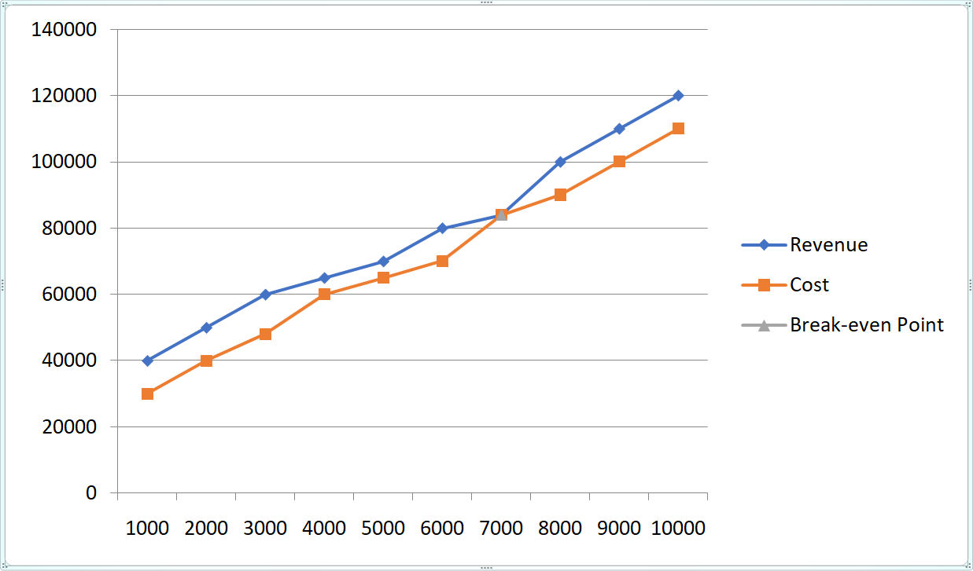

Break-even Analysis

Monthly Revenue Break-even | ₱ 84,000
Assumptions:

Average Percent Variable Cost | 30%
Estimated Monthly Fixed Cost | ₱ 50,000

Projected Profit and Loss
The following table will indicate projected profit and loss. Our losses at start-up are evident, as is the turn of the corner in July when we become profitable.

Pro Forma Profit and Loss
Sales | P940,082 | P1,411,387 | P2,115,697
Direct Cost of Sales | P129,252 | P202,927 | P361,464
Other | 0 | 0 | 0
Total Cost of Sales | P129,252 | P202,927 | P361,464
Gross Margin | P810, 830 | P1,208,460 | P1,754,233
Gross Margin % | 12% | 12% | 12%
Expenses
Payroll | P183,990 | P198,719 | P289,000
Sales and Marketing and Other Expenses | P215,000 | P215,000 | P196,000
Depreciation | 55,000 | 55,000 | 55,000
Leased Equipment | 0 | 0 | 0
Utilities | 110,000 | 110,000 | 110,000
Insurance | 95,000 | 95,000 | 95,000
Rent | 0 | 0 | 0
Payroll Taxes | 140,000 | 140,000 | 140,000
Other | 0 | 0 | 0
Total Operating Expenses | P798,990 | P813,719 | P904,000
Profit Before Interest and Taxes | (452,784) | 410,883 | 638,006
EBITDA | (380,863) | 490,073 | 780,998
Interest Expense | 18,870 | 9,931 | (3,560)
Taxes Incurred | 0 | 286,336 | 0
Net Profit | (P433,914) | P114,616 | P634,446
Net Profit/Sales | -13.65% | 7.51% | 24.32%

Projected Cash Flow
The following chart and table will indicate projected cash flow.

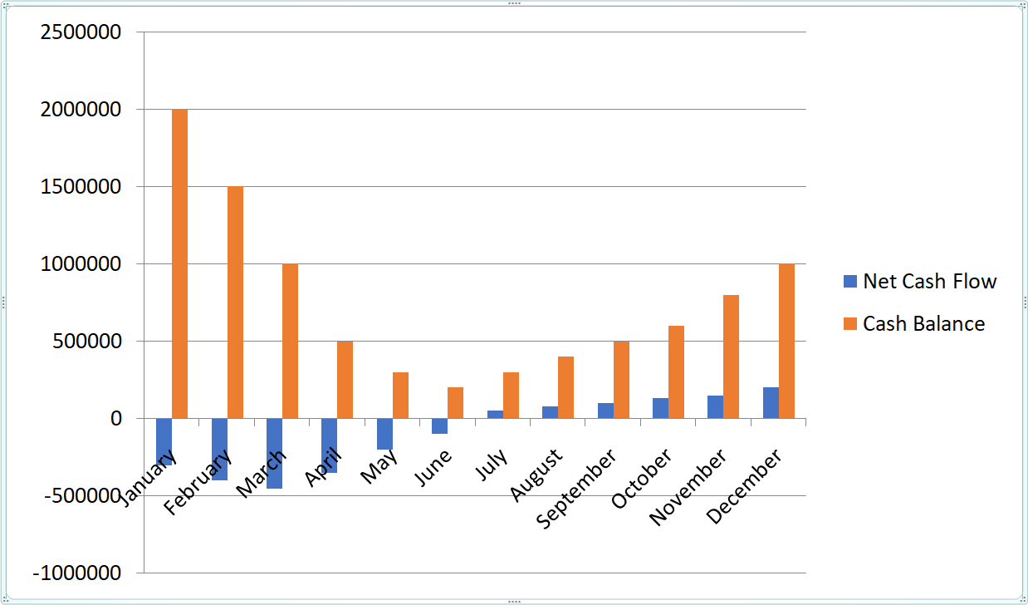

Pro Forma Cash Flow

Cash Received

Cash From Operations

Cash Sales | ₱ 1,567,489 | ₱ 2,385,183 | ₱ 3,103,928
Subtotal Cash From Operations | ₱ 1,567,489 | ₱ 2,385,183 | ₱ 3,103,928
Additional Cash Received

Sales Tax, VAT, HST/GST Received | ₱ 0 | ₱ 0 | ₱ 0
New Current Borrowing | ₱ 0 | ₱ 0 | ₱ 0
New Other Liabilities (Interest Free) | ₱ 0 | ₱ 0 | ₱ 0
New Long-term Liabilities | ₱ 0 | ₱ 0 | ₱ 0
Sales Other Current Assets | ₱ 264,509 | ₱ 298,748 | ₱ 326,749
Sales Of Long-term Assets | ₱ 0 | ₱ 0 | ₱ 0
New Investment Received | ₱ 0 | ₱ 0 | ₱ 0
Subtotal Cash Received | ₱ 1,831,998 | ₱ 2,683,931 | ₱ 3,430,677
Expenditures

Expenditures From Operations

Cash Spending | ₱ 472,847 | ₱ 683,484 | ₱ 1,183,732
Bill Payments | ₱ 75,384 | ₱ 92,857 | ₱ 113,475
Subtotal Spent On Operations | ₱ 548,231 | ₱ 776,341 | ₱ 1,297,207
Additional Cash Spent

Sales Tax, VAT, HST/GST Paid Out | ₱ 124,848 | ₱ 142,948 | ₱ 186,398
Principal Repayment Of Current Borrowing | ₱ 0 | ₱ 0 | ₱ 0
Other Liabilities Principal Repayment | ₱ 0 | ₱ 0 | ₱ 0
Long-term Liabilities Principal Repayment | ₱ 0 | ₱ 0 | ₱ 0
Purchase Other Current assets | ₱ 0 | ₱ 0 | ₱ 0
Purchase Long=term Assets | ₱ 0 | ₱ 0 | ₱ 0
Dividends | ₱ 0 | ₱ 0 | ₱ 0
Subtotal Cash Spent | ₱ 673,079 | ₱ 919,289 | ₱ 1,283,605
Net Cash Flow | ₱ 1,158,919 | ₱ 1,764,642 | ₱ 2,147,072
Cash Balance | ₱ 1,158,919 | ₱ 2,923,561 | ₱ 5,070,633

Balance Sheet
The following table will indicate the projected balance sheet.
Pro Forma Balance Sheet
Assets
Current Assets
Cash | P 117, 735 | P 193,800 | P 732,000
Accounts Receivable | P 188, 640 | P 282,810 | P 428,670
Inventory | P 21,570 | P 32,340 | P 49,020
Other Current Assets | P 7,500 | P 7,500 | P 7,500
Total Current Assets | P 335,445 | P 516, 450 | P 1,217,190
Long-term Assets
Long-term Assets | P 379,500 | P 379,500 | P 379,500
Accumulated Depreciation | P 37,980 | P 75,960 | P 113,940
Total Long-term Assets | P 341,520 | P 303,540 | P 265,560
Total Assets | P 759, 000 | P 759, 000 | P 759, 000
Liabilities and Capital | Year 1 | Year 2 | Year 3
Current Liabilities
Accounts Payable | P 46,260 | P 50,595 | P 75,765
Current Borrowing | P 39,000 | P 3,000 | P 66,765
Other Current Liabilities | P 0 | P 0 | P 0
Subtotal Current Liabilities | P 85, 260 | P 53, 595 | P 142, 530
Long-term Liabilities | P 0 | P 0 | P 0
Total Liabilities | P 85, 260 | P 53, 595 | P 142, 530
Paid-in Capital | P 909,000 | P 909,000 | P 909,000
Retained Earnings | (P 76,500) | (P 317,295) | (P 142,605)
Earnings | (P 240,795) | P 174,690 | P 649,575
Total Capital | P 591,705 | P 766,395 | P 1,415,970
Total Liabilities and Capital | P 676,965 | P 819,990 | P 1,558,500
Net Worth | P 591,705 | P 766,395 | P 1,415,970

Attachment
This attachment show the layout of the restaurant together with its farm.



